Spelling Reading Minutes

**Monday**

**clerk term**

**herd skirt**

**sir**

**Tuesday**

**stir churn**

**burst hurt**

**turn**

**Wednesday**

**(review and challenge)**

start storm

hours problem

usually

**Thursday**

Practice all words

Monday

Tuesday

Wednesday

Thursday

Total Minutes



Math Homework

2 math sheets

Unit 6



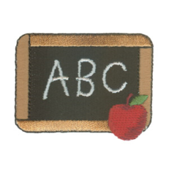 Vocabulary

wider, saddest, balance,

deserted, freezes, imagine



Comment/Questions

Use vocabulary words in conversation with your child this week.

Teaching words with r controlled vowels (ex. er/ir/ur). Find these in books you read at home this week.

Please send this back on Friday.

Study Spelling

* Monday
* Tuesday
* Wednesday
* Thursday

Parent Signature_____________________